Engineering
Primary design
Adhesion module
Figure 2.2.1 Biobircks of adhesion primary design, ① pSB-Pasr-cp19k-mSandy; ② pSB-J23119-cp19k-mSandy; ③ pSB-Pasr-mSandy-Control; ④ pSB-J23119-mSandy-Control. Our key adhesion protein is cp19k (BBa_ 4716014), the 19 kDa cement protein, was extracted from Pollicipes pollicipes and have an adhesion effect. We put its genetic sequence on the cell membrane of E. coli in the hope that it will help the bacteria adhere; It's like glue, sticking bacteria to the intestines.

When choosing our key protein, the adhesion protein, we saw that cp19k, as a new type of adhesion protein, not only has a strong adhesion ability, but also can self-assemble to complete adhesion, which is very simple (compared to other Adhesion proteins - may require other enzyme catalysis to have an adhesion effect).

The asr promoter (or Pasr promoter)
In view of the immune overstimulation in the intestine caused by 33-mer becoming an antigen, which leads to celiac disease, we try to place engineered bacteria that secretes gluten enzyme into the intestine to alleviate this immune response; the first step should be to ensure that the bacteria can stay in the intestine- colonization.

The first question to ensure colonization is: where to colonize? Because the immune response caused by 33-mer is mainly in the small intestine, we want to break down the 33-mer by gluten enzyme before it reaches the small intestine - at least before it causes a comprehensive immune response. Therefore, we chose to let the engineered bacteria colonize the duodenum in the front part of the small intestine.

However, the pH fluctuates greatly at this location and is acidic, so in the end we chose the asr promoter induced by an acidic environment to express the adhesion protein cp19k.

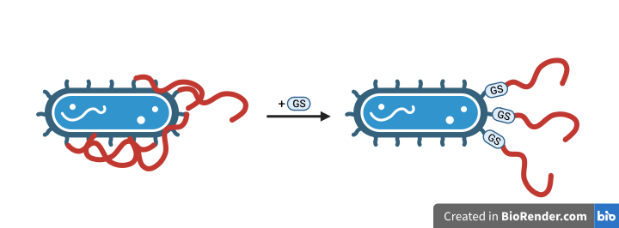
GS linker
While we were performing the literature research of cp19k, we thought that a GS linker should be added between bacteria and cp19k to provide more space for cp19k to stretch and show its adhesion ability; otherwise, CP19K is likely to stick directly to the surface of the bacteria because there is not enough space to stretch, thereby weakening the ability of bacteria to adhere to the intestine - imagine when you tear off a long piece of tape ready to use, the long tape will be very easy to stick to our hands first instead of where we want to stick - GS linker is like a stick to pick the adhesion protein cp19k away, reducing the probability of CP19k all sticking to the bacteria.
Figure 2.2.2 The work of GS linker.

mSandy (mSandy2)
This is a new type of protein, and we want to use this reporter protein, which may be brighter than mCherry, to show our recombinant protein expression, hoping to aid our experiments. Because cp19k with a size of 519 bp may be expressed at a low level, a reporter protein with too little brightness may not be detected, so ultimately we intend to use mSandy.

Release module:
Figure 2.2.3 Biobircks of release primary design, ① pET-Pasr-Fvp-sfGFP; ② pET-Pasr-PEP-sfGFP; ③ pET-J23119-Fvp-sfGFP; ④pET-J23119-Fvp-sfGFP; ⑤ pET-Pasr-sfGFP-Control; ⑥ pET-J23119-sfGFP-Control. Our key proteins are gluten enzymes (Fvp-p and PEP); the asr promoter expression protein is then still selected.

Gluten enzyme
There are a lot of oral gluten enzymes for celiac disease, and we start with oral enzymes to find the protein we want. At present, the more widely used on the market are AN-PEP and PEP enzymes, and we can find these two enzymes from the market or from a large number of studies. However, these two enzymes also have some defects, such as (1) they cannot adapt to the environment of pH instability in the gastrointestinal tract (close to the stomach) - we know that enzymes are extremely sensitive to changes in pH, and even a slight change in acidity may greatly reduce the activity of enzymes; (2) The decomposition efficiency of gluten is low, if most of the 33-mer cannot be removed in time due to low decomposition efficiency, it will still cause the patient's immune response. In the end, we chose Fvp-p (Fvp) and PEP as the secreted proteins of engineered bacteria as the core proteins of our treatment. PEP is resistant to petroprotein hydrolysis and adapts to acidic environment (pH2-3 is still stable and active); Fvp has more pairs of 33-mer pairs of shear sites, giving it efficient decomposition efficiency; Selected by us.

Secondary design:

Adhesion module:
Figure 2.2.4 Biobircks of adhesion secondary design. When we were detecting cp19k expression with pSB-J23119-cp19k-mSandy, we found a problem with J23119.

As soon as we found the problem, we sequenced the plasmid and found that J23119 had a single point mutation and some deletion mutations:
- pSB-J23119-mSandy-Control: g.2055_2056del
- pSB-J23119-cp19k-mSandy-Control: g.2055_2071del

Then we modified the plasmid with primer and got a new, correct plasmid; finally, we performed our experiment with the correct plasmid.

Release module:
Figure 2.2.5 Biobircks of release primary design. ① pET-NorR-ProA-NorV-Fvp-his; ② pET-NorR-ProA-NorV-Fvp-his; ③ pET-NorR-ProA-NorV-his-Control. The key protein still is our gluten enzymes; The highlight is the NO promoter, which was added by paper study. Another small improvement is the use of GFP reporter proteins into his tags for subsequent protein expression detection - because the sequence of GFP proteins is too long, resulting in a large size of the entire plasmid, which can seriously affect the expression of key proteins.

NO sensor
While maintaining the original plan, we are also exploring more targeted and sensitive activation switches for celiac disease conditions; After a period of literature review and understanding of similar projects by previous iGEM teams, we decided to conduct the first iteration of our release module through the relationship between celiac disease and intestinal inflammation, and finally chose the most suitable module for NO sensor. Here's a brief description of how it starts.
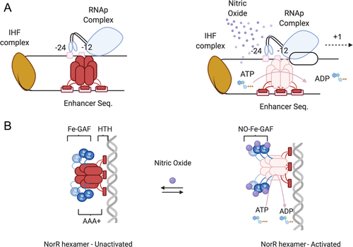
Figure 2.2.6 NO sensor mechanism. Molecular mechanism of NorR-mediated σ54-dependent transcriptional activation. (A) P_{NorV} promoter in its off state. Integration host factors (yellow) bend DNA with a near 160° sharp angle to allow the NorR (Red) homohexamer to come in contact with the σ factor at its binding sites (−24 and −12). NorR binding with the upstream enhancer sequence is shown in the pink block. In the absence of the inducer, the RNAp complex is closed from transcription. Upon nitric oxide binding, NorR exposes its AAA+ ATPase domain and activates σ into its active form for DNA opening and transcriptional initiation. (B) The way NorR interacts with nitric oxides is through its nonhaem iron center (blue), which signals a reversible conformation change that opens up the ATPase domain upon binding.

Further study:
Adhesion module:
Figure 2.2.7 Biobrick of the new part. We tried to compare the adhesion effect of cp19k with mefp5, so we replaced the key protein with mefp5 to become a new plasmid.

When we conducted cp19k-related experiments, we found that the UM_Macau iGEM team in 2019 also used an adhesion protein with strong adhesion ability-mefp5, and the relevant literature resources are rich and the application scenarios seem to be more extensive. So we want to try to compare cp19k and mefp5 in future studies to observe the adhesion effect of the two adhesion proteins in the intestinal environment. However, due to the short schedule and lack of time, we only completed the design of the plasmid and did not fully carry out the experiment.

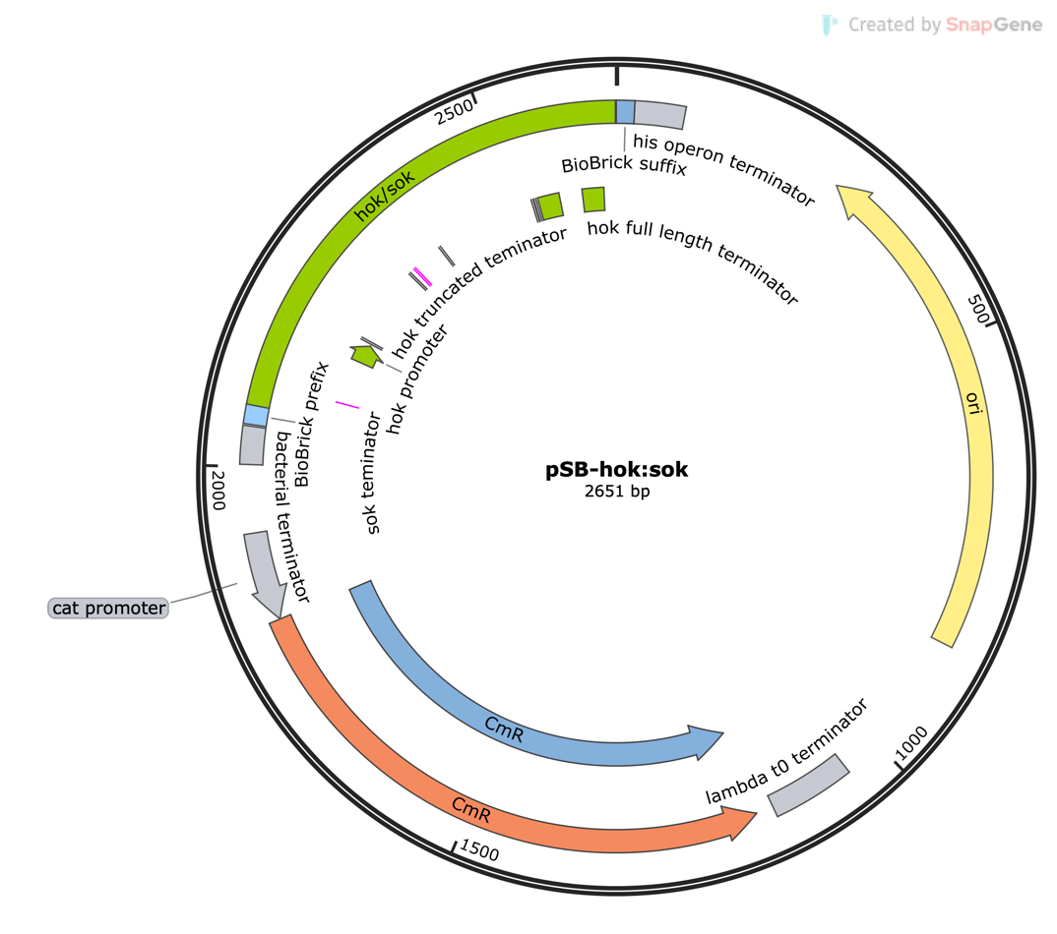
Safety control:
Figure 2.2.8 Plasmid map of the safety control.
The safety of the engineered bacteria in the environment and in patients themselves are also important considerations in the realization of the most important functional modules of our project. Our safety module is divided into two main parts: in vitro and in vivo.
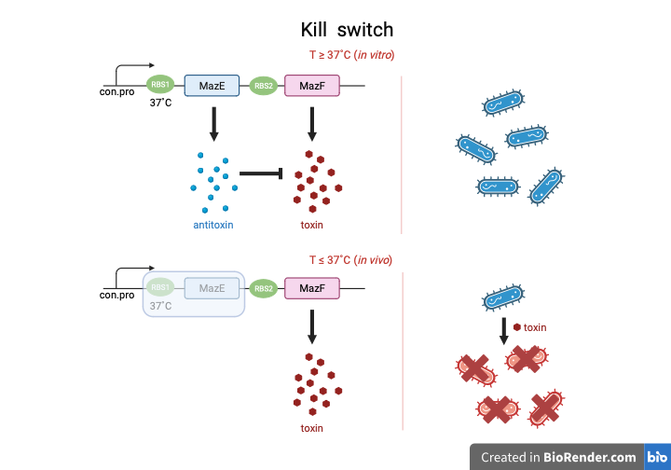
Figure 2.2.9 Temperature control switch diagram.
The toxin/antitoxin system, widely used both inside and outside of the iGEM competition, is a proven and robust system for building flora suicide switches. When our implanted intestinal flora is expelled from the body for various reasons, we ensure that it will not be potentially contaminated to other natural environment microorganisms due to the uncontrolled horizontal gene transfer of our additional adhesion and releasing modules we have added to the intestinal flora. Based on the human body temperature of around 37 degrees Celsius, we chose a temperature controlled suicide switch based on Part:BBa_K3247005 RNA thermometer NoChill-06. When our engineered bacteria are expelled from patient’s body, the module that manipulates the expression of the antitoxin stops due to the temperature deviation from 37 degrees Celsius, terminating the inhibition of the toxin, and realising its suicide in the natural environment after it is expelled.

